LAB PROGRAMS- OPERATING SYSTEM

K. Tejaswi
RegNo: 192525407

1)
CREATE A NEW PROCESS BY INVOKING THE APPROPRIATE SYSTEM CALL. GET THE PROCESS IDENTIFIER OF THE CURRENTLY RUNNING PROCESS AND ITS RESPECTIVE PARENT USING SYSTEM CALLS AND DISPLAY THE SAME USING A C PROGRAM

AIM:
Create a new process by invoking the appropriate system call. Get the process identifier of the currently running process and its respective parent using system calls and display the same using a C program.

PROGRAM:
#include<stdio.h>
#include<unistd.h>
int main() {
printf("Process ID: %d\n", getpid() );
printf("Parent Process ID: %d\n", getpid() );
return 0;
}
OUTPUT
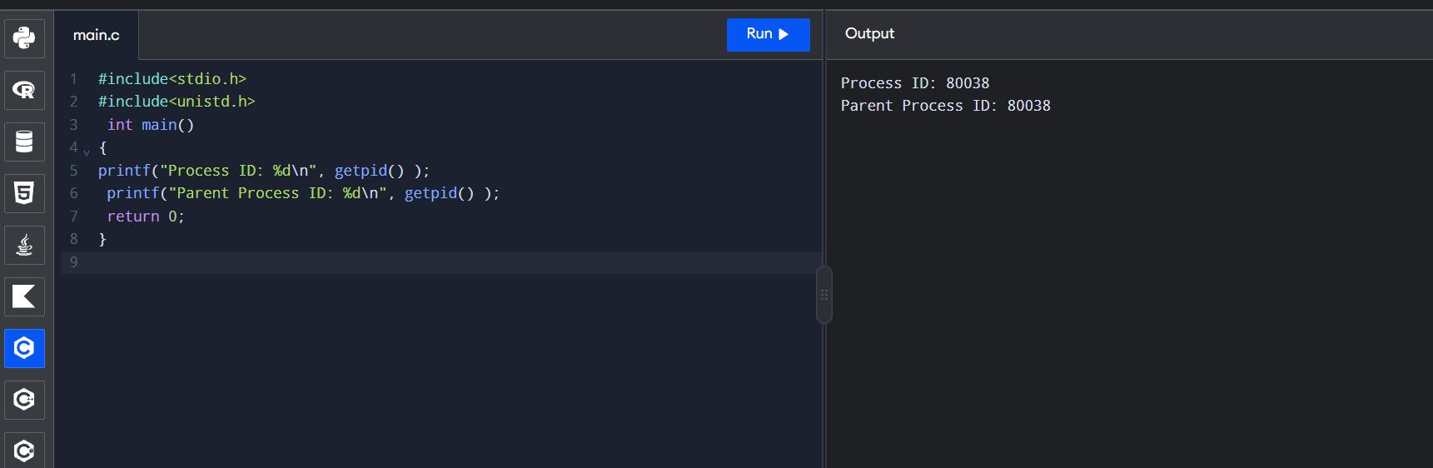

2)
IDENTIFY THE SYSTEM CALLS TO COPY THE CONTENT OF ONE FILE TO ANOTHER AND ILLUSTRATE THE SAME USING A C PROGRAM

AIM:
Identify the system calls to copy the content of one file to another and illustrate the same using a C program

PROGRAM:
#include <stdio.h>
#include <stdlib.h>
int main()
{
FILE *fptr1, *fptr2;
char filename[100], c;
printf("Enter the filename to open for reading \n");
scanf("%s", filename);
fptr1 = fopen(filename, "r");
if (fptr1 == NULL)
{
printf("Cannot open file %s \n", filename);
exit(0);
}
printf("Enter the filename to open for writing \n");
scanf("%s", filename);
fptr2 = fopen(filename, "w");
if (fptr2 == NULL) { printf("Cannot open file %s \n", filename);
exit(0);
}
c = fgetc(fptr1);
while (c != EOF) { fputc(c, fptr2);
c = fgetc(fptr1);
}
printf("\nContents copied to %s", filename);
fclose(fptr1);
fclose(fptr2);
return 0;
}

OUTPUT:
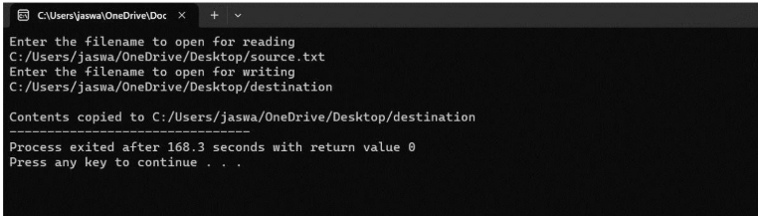

3)
IMPLEMENT A C PROGRAM FOR PRODUCER AND CONSUMER FOR COOPERATION PROCESS
Aim:
To implement the Bounded Buffer (Producer–Consumer) problem in C using an array as a circular buffer, demonstrating buffer insertion and deletion operations.

Program:
#include <stdio.h>

#define BUFFER_SIZE 10

int buffer[BUFFER_SIZE];
int in = 0, out = 0, count = 0;

void produce(int item)
{
if (count == BUFFER_SIZE)
{
printf("Buffer is full!\n");
return;
}

buffer[in] = item;
in = (in + 1) % BUFFER_SIZE;
count++;

printf("Produced: %d\n", item);
}

void consume()
{
if (count == 0)
{
printf("Buffer is empty!\n");
return;
}

printf("Consumed: %d\n", buffer[out]);
out = (out + 1) % BUFFER_SIZE;
count--;
}

int main()
{
int choice, item;

while (1)
{
printf("\n1. Produce\n");
printf("2. Consume\n");
printf("3. Exit\n");
printf("Enter your choice: ");
scanf("%d", &choice);

switch (choice)
{
case 1:
printf("Enter item: ");
scanf("%d", &item);
produce(item);
break;

case 2:
consume();
break;

case 3:
return 0;

default:
printf("Invalid choice!\n");
}
}

return 0;
}
Output:
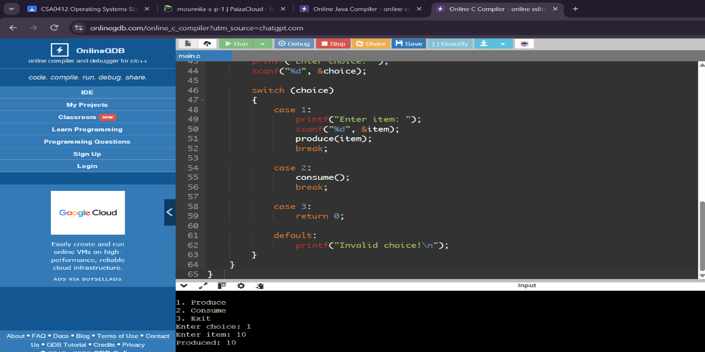

4) IMPLEMENTATION OF SOCKET PROGRAMMING USING TCP OR UDP
Aim:
To implement tcp socket programming in c to establish communication between a client andserver and exchange messages using socket functions

Program:
Server:
#include <stdio.h>
#include <string.h>
#include <unistd.h>
#include <sys/socket.h>
#include <netinet/in.h>

int main()
{
int s, c, n;
struct sockaddr_in addr;
char msg[100];

s = socket(AF_INET, SOCK_STREAM, 0);

addr.sin_family = AF_INET;
addr.sin_port = htons(8080);
addr.sin_addr.s_addr = INADDR_ANY;

bind(s, (struct sockaddr *)&addr, sizeof(addr));
listen(s, 1);

printf("Server waiting for client...\n");
c = accept(s, NULL, NULL);
printf("Client connected!\n");

while (1)
{
n = recv(c, msg, 99, 0);
if (n <= 0) break;

msg[n] = '\0';
printf("Client: %s", msg);

if (strncmp(msg, "bye", 3) == 0) break;

printf("Server: ");
fgets(msg, 100, stdin);
send(c, msg, strlen(msg), 0);

if (strncmp(msg, "bye", 3) == 0) break;
}

close(c);
close(s);
return 0;
}

Client :

#include <stdio.h>
#include <string.h>
#include <unistd.h>
#include <sys/socket.h>
#include <arpa/inet.h>

int main()
{
int s, n;
struct sockaddr_in server;
char msg[100];

s = socket(AF_INET, SOCK_STREAM, 0);

server.sin_family = AF_INET;
server.sin_port = htons(8080);
server.sin_addr.s_addr = inet_addr("127.0.0.1");

if (connect(s, (struct sockaddr *)&server,
sizeof(server)) < 0)
{
printf("Connection failed!\n");
close(s);
return 1;
}

printf("Connected to server!\n");

while (1)
{
printf("Client: ");
if (fgets(msg, sizeof(msg), stdin) == NULL)
break;

send(s, msg, strlen(msg), 0);

if (strncmp(msg, "bye", 3) == 0)
break;

n = recv(s, msg, sizeof(msg) - 1, 0);

if (n <= 0)
break;

msg[n] = '\0';
printf("Server: %s", msg);

if (strncmp(msg, "bye", 3) == 0)
break;
}

close(s);
return 0;
}
gcc server.c -o server
./server
gcc client.c -o client
./client

Output:
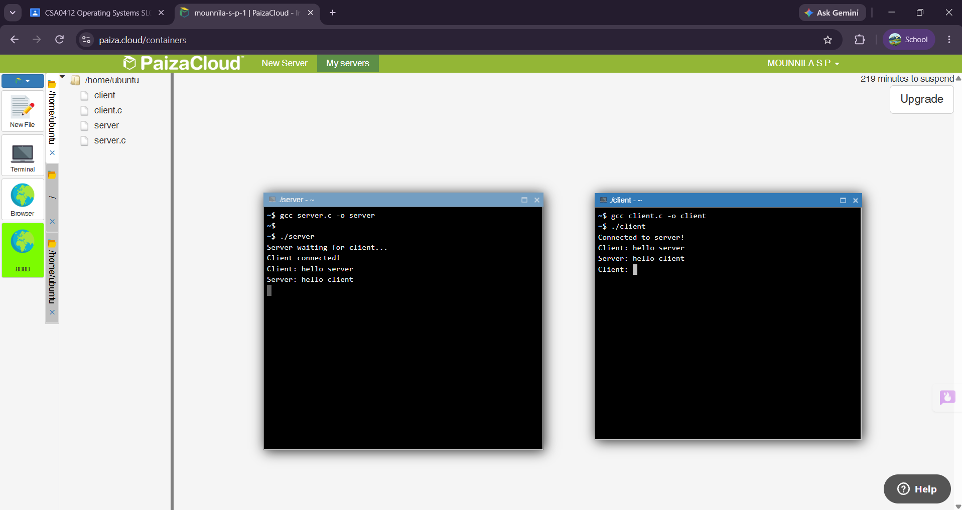

5)IMPLEMENTATION OF JAVA PROGRAMMING USING MULTITHREADING

Aim:
To write a java programming using multithreading
Program:

class MyThread extends Thread {
public void run() {
for (int i = 1; i <= 5; i++) {
System.out.println(
Thread.currentThread().getName() + ": " + i
);
}
}
}

public class Main {
public static void main(String[] args) {
MyThread t1 = new MyThread();
MyThread t2 = new MyThread();

t1.setName("Thread 1");
t2.setName("Thread 2");

t1.start();
t2.start();
}
}

Output:
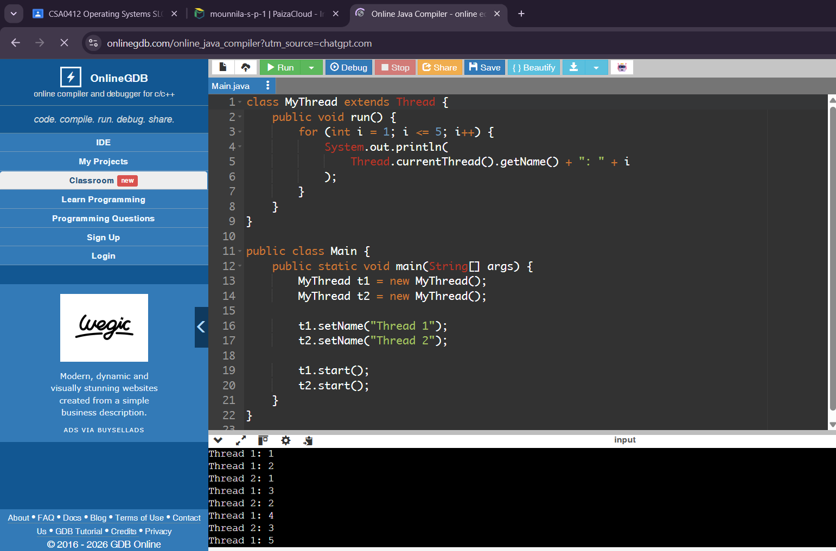

5) CONSTRUCT A C PROGRAM TO IMPLEMENT PREEMPTIVE PRIORITY SCHEDULING ALGORITHM
Aim:
To write and execute a C program to implement the Preemptive Priority Scheduling Algorithm and calculate Waiting Time and Turnaround Time for each process.
Programe:
#include <stdio.h>

int main()
{
int n, i, time = 0, completed = 0;
int at[20], bt[20], rt[20], pr[20];
int ct[20], wt[20], tat[20];
int min, pos;
float avgwt = 0, avgtat = 0;

printf("Enter number of processes: ");
scanf("%d", &n);

for(i = 0; i < n; i++)
{
printf("Enter Arrival Time, Burst Time and Priority of P%d: ", i+1);
scanf("%d%d%d", &at[i], &bt[i], &pr[i]);
rt[i] = bt[i];
}

while(completed < n)
{
min = 999;
pos = -1;

for(i = 0; i < n; i++)
{
if(at[i] <= time && rt[i] > 0 && pr[i] < min)
{
min = pr[i];
pos = i;
}
}

if(pos == -1)
{
time++;
continue;
}

rt[pos]--;
time++;

if(rt[pos] == 0)
{
completed++;
ct[pos] = time;
}
}

printf("\nProcess\tAT\tBT\tPriority\tWT\tTAT\n");

for(i = 0; i < n; i++)
{
tat[i] = ct[i] - at[i];
wt[i] = tat[i] - bt[i];

avgwt += wt[i];
avgtat += tat[i];

printf("P%d\t%d\t%d\t%d\t\t%d\t%d\n",
i+1, at[i], bt[i], pr[i], wt[i], tat[i]);
}

printf("\nAverage Waiting Time = %.2f", avgwt/n);
printf("\nAverage Turnaround Time = %.2f\n", avgtat/n);

return 0;
}

Output:
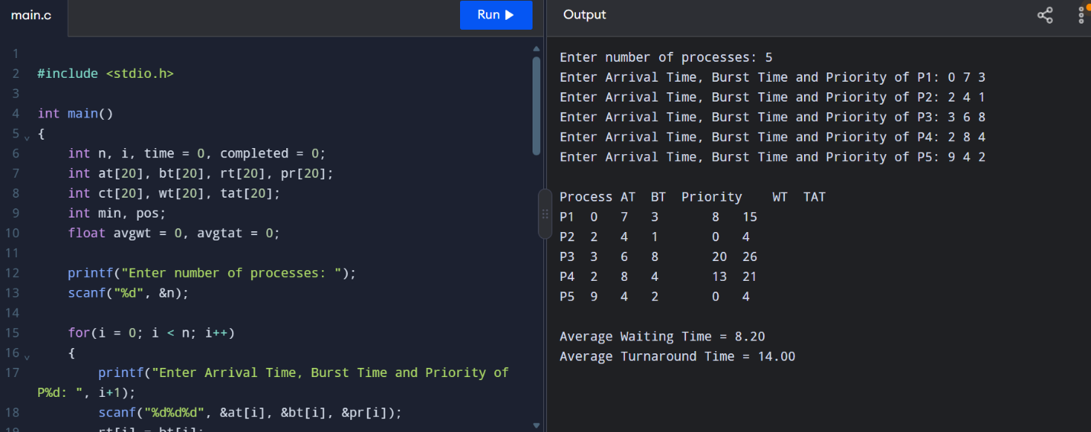

Result:
Thus, the Preemptive Priority Scheduling Algorithm was successfully implemented using C programming, and the Waiting Time and Turnaround Time were calculated.

